Project Design Phase-I

**Solution Architecture**

|  |  |
| --- | --- |
| Team ID | LTVIP2023TMID07965 |
| Project Name | Classification of arrhythmia by using deep learning with 2-d ecg spectral image representation |
| Maximum Marks | 4 Marks |

**Minimum Viable Architecture for MVP**

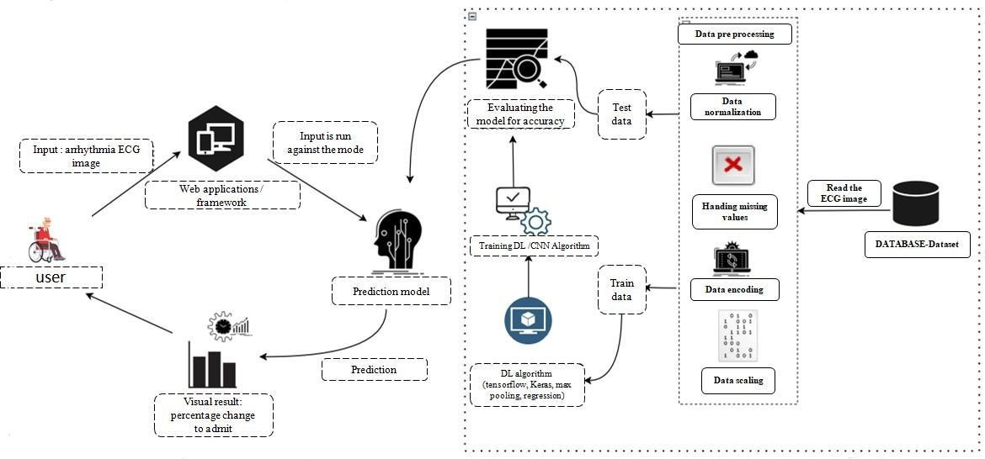

# Technologies needed for Minimum Viable Product deployment

* Working with HTML & CSS Using Frontend
* Working with image processing technique
* Working with Tensorflow capabilities
* Working with Keras capabilities
* Working Trained CNN model
* Build a web application using the Flask framework

# Platform

* Git & GitHub - Project Management
* IBM Cloud - Hosting
* IBM Watson - Training the Deep Learning Mode

